AIM : To study basic SQL queries (CREATE, INSERT, SELECT)

TABLES CREATED:

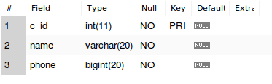
- Costumer

QUERIES RUN :

- INSERT INTO costumer VALUES(1, "Chetan Gupta", 7042869567);
- INSERT INTO costumer VALUES(2, "Anmol Singh", 9801234523);
- INSERT INTO costumer VALUES(3, "Deepanshu", 9835253747);
- INSERT INTO costumer VALUES(4, "Siddharth Nayyar", 9837251537);
- INSERT INTO costumer VALUES(5, "Neeraj Verma", 8798973546);

- SELECT * FROM costumer;
